SOCIAL MEDIA TOOLKIT

The aim of the toolkit is to promote your participation at the “European SDG Summit 2021: For Climate Action & a Just Transition”.
We encourage you to:
- Tell us why you are looking forward to the European SDG Summit 2021:
- Explain why you'll be attending or which session you are co-organising.
- Record a short video clip of your team saying, "we'll be attending – how about you?".
- Reach out to your contacts to invite them to 'meet' virtually during the Summit on the event platform.
- Share the suggested posts below (see page 2-3) on your social media channels.
- Feel free to modify the text.
- Retweet, like, and/or reply to CSR Europe's posts about the SDG Summit 2021
- Make sure to follow us on Twitter – click on the bell icon to be notified of our posts - and on LinkedIn.

Whichever option you choose, make sure to:
- Use the event hashtag: #SDGSummit
- Tag us: @CSREuropeOrg on twitter; @CSREurope on LinkedIn.
- To save space, tag us on the picture, instead of the text.
HOW FREQUENTLY YOU SHOULD POST:
- Twitter: Tweets are fleeting, so you can post frequently. The average Tweet lasts 18 minutes in people's feeds before it is replaced by all the new content coming out.
- LinkedIn: Posts on LinkedIn are often recycled, so 1 post every two weeks at most is recommended.

SUGGESTED SOCIAL MEDIA POSTS
LINKEDIN
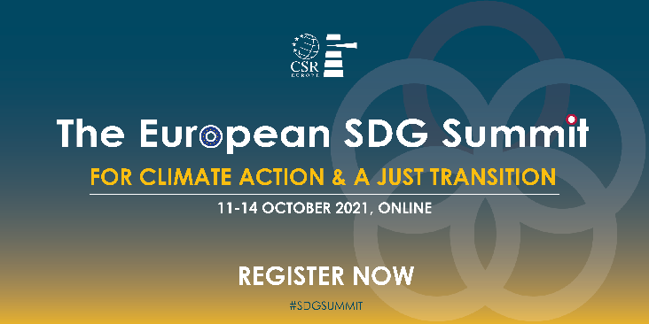
Download the graphic

𝗜 𝘄𝗶𝗹𝗹 𝗮𝘁𝘁𝗲𝗻𝗱 𝘁𝗵𝗲 #𝗦𝗗𝗚𝗦𝘂𝗺𝗺𝗶𝘁 𝟮𝟬𝟮𝟭: 𝗙𝗼𝗿 𝗖𝗹𝗶𝗺𝗮𝘁𝗲 𝗔𝗰𝘁𝗶𝗼𝗻 & 𝗮 𝗝𝘂𝘀𝘁 𝗧𝗿𝗮𝗻𝘀𝗶𝘁𝗶𝗼𝗻 - organised by @CSR Europe – on 11-14 October!

𝗝𝗼𝗶𝗻 𝗺𝗲 𝗮𝗻𝗱 𝗿𝗲𝗴𝗶𝘀𝘁𝗲𝗿 𝗻𝗼𝘄 👉 https://bit.ly/3wI4teu

In the face of a climate crisis and weakened social cohesion, 𝘁𝗵𝗲 𝗘𝘂𝗿𝗼𝗽𝗲𝗮𝗻 𝗦𝗗𝗚 𝗦𝘂𝗺𝗺𝗶𝘁 𝟮𝟬𝟮𝟭 will bring together 5.000+ Thought Leaders 𝗶𝗻 𝟯𝟬 𝗳𝘂𝗹𝗹𝘆 𝗳𝗿𝗲𝗲 𝗮𝗻𝗱 𝘃𝗶𝗿𝘁𝘂𝗮𝗹 𝘀𝗲𝘀𝘀𝗶𝗼𝗻𝘀 𝘁𝗼 𝗯𝘂𝗶𝗹𝗱 𝗮 𝗽𝗿𝗼𝘀𝗽𝗲𝗿𝗼𝘂𝘀 𝗮𝗻𝗱 𝗶𝗻𝗰𝗹𝘂𝘀𝗶𝘃𝗲 𝘀𝗼𝗰𝗶𝗲𝘁𝘆 𝘄𝗵𝗶𝗹𝗲 𝗽𝘂𝗿𝘀𝘂𝗶𝗻𝗴 𝗮 𝗴𝗿𝗲𝗲𝗻, 𝗮𝗻𝗱 𝗱𝗶𝗴𝗶𝘁𝗮𝗹 𝘁𝗿𝗮𝗻𝘀𝗶𝘁𝗶𝗼𝗻.

SUGGESTED HASHTAGs: #SDGSummit #SDGs #leadership #sustainability
WHO TO TAG: @CSREurope
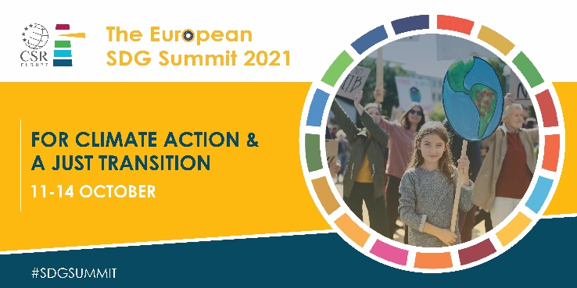

Download the graphic.

𝗝𝗼𝗶𝗻 𝗺𝗲 𝗮𝘁 𝘁𝗵𝗲 𝗘𝘂𝗿𝗼𝗽𝗲𝗮𝗻 𝗦𝗗𝗚 𝗦𝘂𝗺𝗺𝗶𝘁 𝟮𝟬𝟮𝟭 𝗼𝗻 𝟭𝟭-𝟭𝟰 𝗢𝗰𝘁𝗼𝗯𝗲𝗿!

The event, organised by @CSR Europe, will bring together 5000+ Sustainability Leaders in 30 virtual sessions to accelerate the journey towards climate neutrality and the adoption of an inclusive approach to the green and digital transition.

After registering – for free - you will have access to:
✔️ 4 𝗛𝗶𝗴𝗵-𝗹𝗲𝘃𝗲𝗹 𝗽𝗹𝗲𝗻𝗮𝗿𝗶𝗲𝘀 with guest speakers like Commission Executive Vice-President, 𝗙𝗿𝗮𝗻𝘀 𝗧𝗶𝗺𝗺𝗲𝗿𝗺𝗮𝗻𝘀, 𝗠𝗮𝗶𝗿𝗲𝗮𝗱 𝗠𝗰𝗴𝘂𝗶𝗻𝗻𝗲𝘀𝘀, European Commissioner for Financial Affairs, 𝗡𝗶𝗰𝗼𝗹𝗮𝘀 𝗦𝗰𝗵𝗺𝗶𝘁, European Commissioner for Jobs & Social Rights.

✔️ 𝟮𝟳 𝗶𝗻𝘁𝗲𝗿𝗮𝗰𝘁𝗶𝘃𝗲 𝗘𝘂𝗿𝗼𝗽𝗲𝗮𝗻 𝗮𝗻𝗱 𝗡𝗮𝘁𝗶𝗼𝗻𝗮𝗹 𝗦𝗗𝗚 𝗥𝗼𝘂𝗻𝗱𝘁𝗮𝗯𝗹𝗲𝘀

✔️ 𝗤𝘂𝗮𝗹𝗶𝘁𝘆 𝗻𝗲𝘁𝘄𝗼𝗿𝗸𝗶𝗻𝗴 on the Summit’s virtual platform

Register now: https://bit.ly/3wI4teu
SUGGESTED HASHTAGs: #SDGSummit #SDGs #leadership #sustainability
WHO TO TAG: @CSREurope

TWITTER
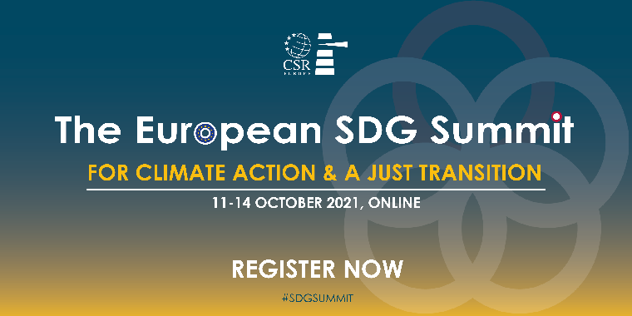
Download the graphic.

Are you interested in building an inclusive society while pursuing a green, and digital transition?
Join me and 5.000 #ThoughtLeaders at the #SDGSummit on 11-14 October 2021!
Register now and get free access to the 30 virtual sessions of the event 👉 https://bit.ly/3wI4teu
SUGGESTED HASHTAGs: #SDGSummit
WHO TO TAG: @CSREuropeOrg
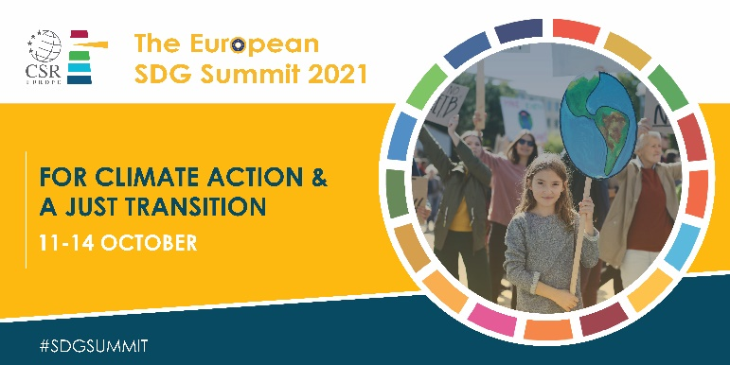
Download the graphic

I will join @CSREuropeOrg at the #SDGSummit on 11-14 October 2021!
Register now and access for free the 30 virtual sessions in programme and contribute to the dialogue on #climateaction and a #JustTransition.
👉 https://bit.ly/3wI4teu

SUGGESTED HASHTAGs: #SDGSummit
WHO TO TAG: @CSREurope

